Rounding Numbers - Answers

Key Stage 2: 2003 Paper A
1.
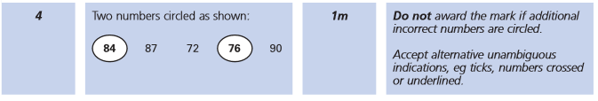
Key Stage 2: 2006 Paper B
1.
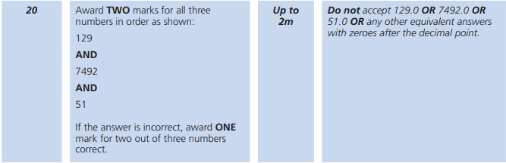
Key Stage 2: 2009 Paper B
1.
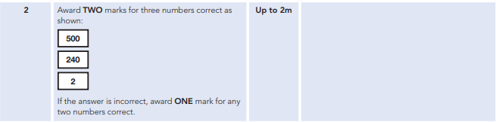
Key Stage 2: 2010 Paper A
1.

Key Stage 2: 2010 Paper B
1.
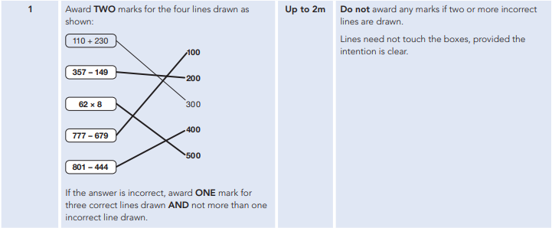
Key Stage 2: 2012 Paper A L6
1.
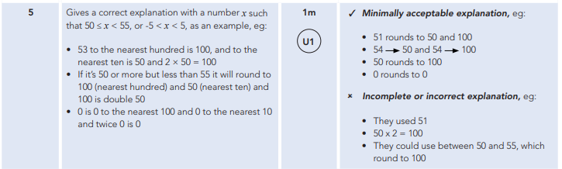
Key Stage 2: 2012 Paper A
1.
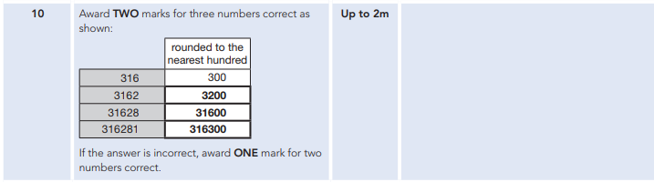

Key Stage 2: 2013 Paper A
1.
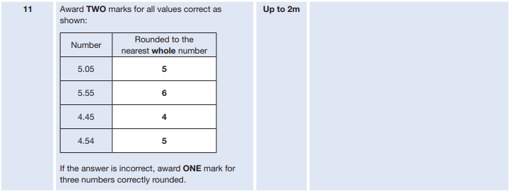
Key Stage 2: 2013 Paper B
1.
Key Stage 2: 2014 Paper B L6
1.
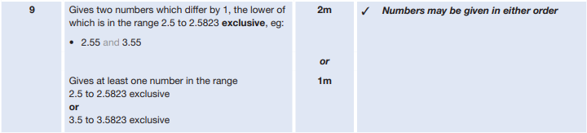
Key Stage 2: 2015 Paper A
1.
Key Stage 2: 2015 Paper B
1.

Key Stage 2: 2016 Paper 2 Reasoning - Sample
1.
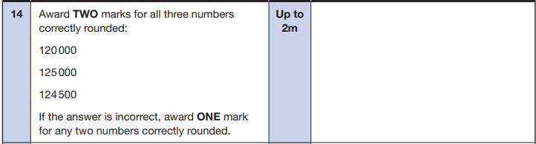
Key Stage 2: 2016 Paper 3 Reasoning - Sample
1.
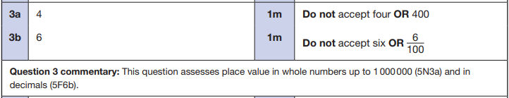
Key Stage 2: 2016 Paper 3 Reasoning
1.
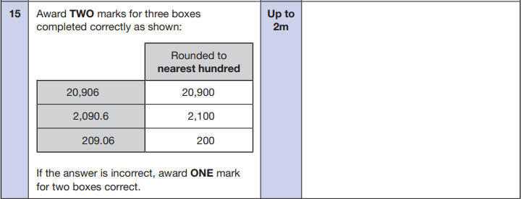

Key Stage 2: 2017 Paper 2 Reasoning
1.
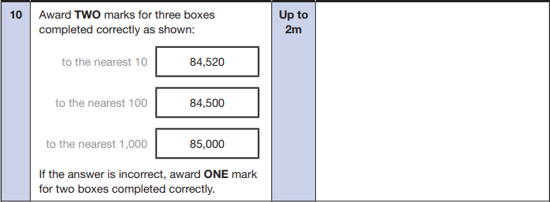
Key Stage 2: 2018 Paper 2 Reasoning
1.
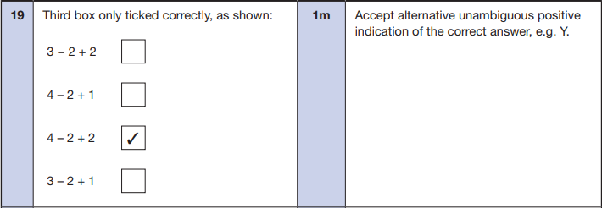
Key Stage 2: 2019 Paper 2 Reasoning
1.
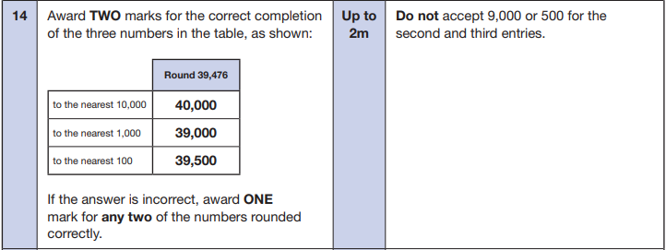

Key Stage 2: 2019 Paper 3 Reasoning
1.
